Programming Assignment 5

In this assignment, you’ll modify the Tip Calculator app presented in this chapter so it uses an EditTextPreference element. Although this type of preference wasn’t described in this chapter, it works similarly to the CheckBoxPreference element, and you can look it up in the documentation for the API if necessary.

When you’re done, a test run should look like this:

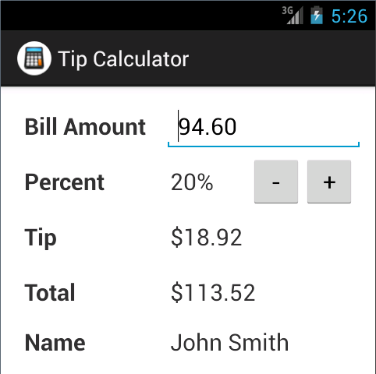

1. Start Android Studio and open the project named ch08_ex4_TipCalculator (PA5 Starter Code).
2. Open the preferences.xml file in the xml directory. Add an EditTextPreference element for a setting named Name. This setting should allow the user to enter his or her full name.
3. Run the app and use the Settings activity to enter your name.
4. Open the layout of the activity. Modify the layout, so it includes a fifth row that can display a name.
5. Open the class for the Tip Calculator activity. Modify this code so it gets the name from the preferences and displays that name in the fifth row.